Designing a synchronous finite state machine (FSM) is a common task for a digital logic engineer.

A finite state machine is a hardware component that advances from the
current state to the next state at the clock edge. This section discusses
methods and strategies for state machine encoding.

State Encoding Methods for State
Machines
There are several ways to encode a state machine, including sequential
(binary), gray code, and one-hot encoding. State machines with sequentially
encoded states have minimal numbers of flip-flops and wide combinatorial
functions. However, most FPGAs have many flip-flops and relatively narrow
combinatorial function generators. Sequential or gray-code encoding
schemes can result in inefficient implementation in terms of speed and
density for FPGAs. On the other hand, a one-hot encoded state machine
represents each state with one flip-flop. As a result, it decreases the width of
combinatorial logic, which matches well with register rich FPGA architectures.
In general, for FPGA Architectures, sequential or gray code encoding results
in a smaller area implementation and one-hot encoding results in a faster
implementation. For small state machines, less than 5 states, sequential is
typically the default because it only requires two bits so decoding the state is
fairly minimal. For larger state machines, 5 states or greater, one-hot is the
default because even though each state requires a register, the states do not
need to be decoded allowing for better performance.
There are various reasons you may choose to invoke a particular state
machine encoding scheme for a design. For example, you may choose to use
sequential encoding on a large state machine because performance in not
critical and you need to use a lot of register elsewhere in your design. You can
hard code the states in the source code by specifying a numerical value for
each state. This approach ensures the correct encoding of the state machine
but is more restrictive in the coding style. Alternatively, the enumerated coding
style leaves the flexibility of state machine encoding to the synthesis tools.
Most synthesis tools allow you to define encoding styles either through
attributes in the source code or through the tool’s user interface. Each
synthesis tool has its own synthesis attributes and syntax for choosing the
encoding styles. Refer to your synthesis tool’s documentation for details about
attributes syntax and values.

General State Machine Description
Generally, there are two approaches to describing a state machine.

One approach is to use one process or block to handle both state transitions and state outputs.
The other is to separate the state transition and the state outputs into two different processes or blocks.
The latter approach is more straightforward, because it separates the synchronous state registers from
the decoding logic that is used in the computation of the next state and the outputs.

https://pdfs.semanticscholar.org/fb6e/f3e30d912031f76ce1725e24546149ee9339.pdf
https://github.com/NetFPGA/netfpga/wiki/VerilogCodingGuidelines
Basically a FSM consists of combinational, sequential and output logic. Combinational logic is used to decide the next state of the FSM, sequential logic is used to store the current state of the FSM. The output logic is a mix of both combo and seq logic.
Types of State Machines
There are many ways to code these state machines, but before we get into the coding styles, let's first understand the basics a bit. There are two types of state machines:
Mealy State Machine : Its output depends on current state and current inputs
Moore State Machine : Its output depends on current state only.
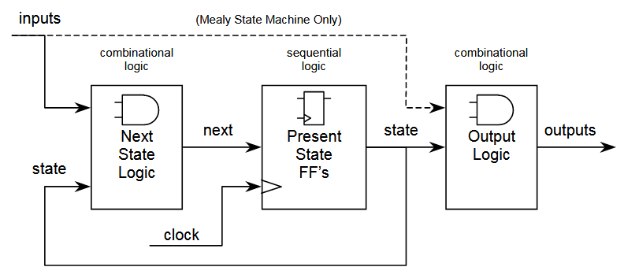

Depending on the need, we can choose the type of state machine. In general, or you can say most of the time, we end up using Mealy FSM.

Encoding Style
Since we need to represent the state machine in a digital circuit, we need to represent each state in one of the following ways:
Binary encoding : each state is represented in binary code (i.e. 000, 001, 010....)
Gray encoding : each state is represented in gray code (i.e. 000, 001, 011,...)
One Hot : only one bit is high and the rest are low (i.e. 0001, 0010, 0100, 1000)
One Cold : only one bit is low, the rest are high (i.e. 1110,1101,1011,0111)

http://www.asic-world.com/tidbits/verilog_fsm.html
https://pdfs.semanticscholar.org/fc86/c86da97e1c56eb791728b5d072ae6b6d1c4f.pdf
Guideline: make state assignments using parameters with symbolic state names.
parameter [4:0] IDLE, S1, S2 , S3, ERROR;
IDLE = 5'b00001,
S1 = 5'b00010,
S2 = 5'b00100,
S3 = 5'b01000,
ERROR = 5'b10000;

Two-Always Block State Machine

A synthesizable state machine may be coded many ways.
Two of the most common, easily understood and efficient methods are two-always block and one-always block state machines.
The easiest method to understand and implement is the two-always block state machine with output assignments included in either the combinational next-state always block or separate continuous-assignment outputs. This method partitions the Verilog code into the major FSM
blocks shown in Figure 1: clocked present state logic, next state combinational logic and output
combinational logic.

We need register to hold the current state
We need next state function
https://courses.cs.washington.edu/courses/cse370/10sp/pdfs/lectures/15-VerilogIIPrint.pdf

- 4-State Mealy State Machine
The outputs of a Mealy state machine depend on both the inputs and the current state. When the inputs change, the outputs are updated without waiting for a clock edge.
- 4-State Moore State Machine
The outputs of a Moore state machine depend only on the present state. The outputs are written only when the state changes (on the clock edge).

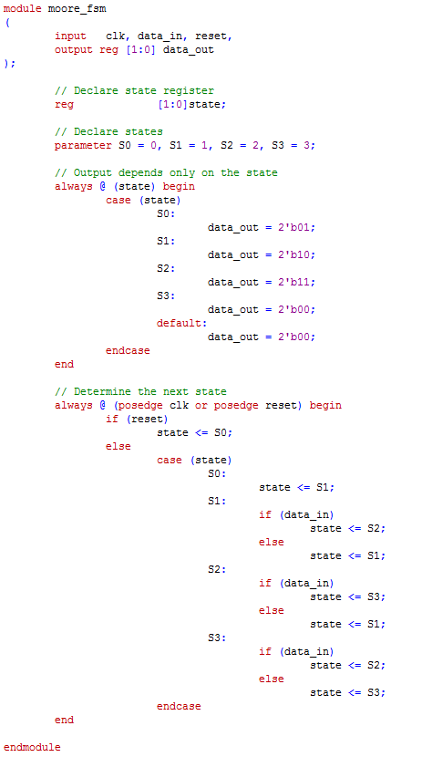

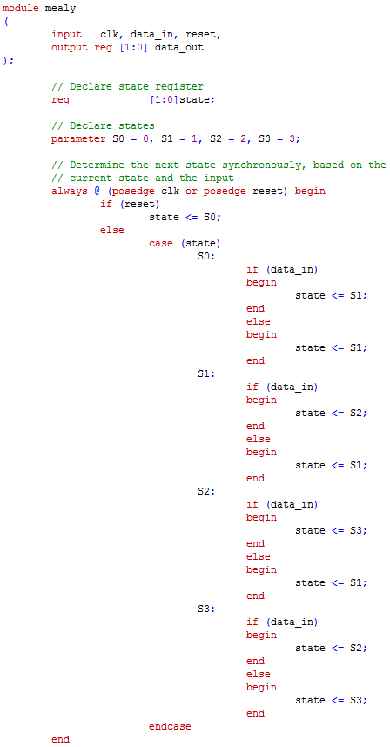

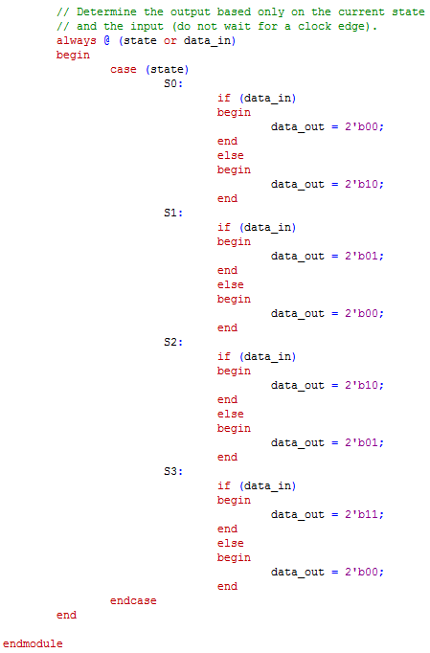

http://www.sunburst-design.com/papers/CummingsICU2002_FSMFundamentals.pdf

always@ blocks are used to describe events that should happen under certain conditions.
always@ blocks are always followed by a set of parentheses, a
begin , some code, and an end

always@( ... sensitivity list ... )
begin

... elements ...

end

always@(posedge Clock)Blocks

Are used to describe sequential Logic, or registers.
Only <= (non-blocking) assignments should be used
Never use = (blocking) assignments
Only use these blocks when you want to infer an element(s) that changes its value at the positive or negative edge of the clock.

always@( * )Blocks
are used to describe Combinational Logic
, or Logic Gates.
Only = (blocking) assignments should be used . Never use <=(non-blocking) assignments
Only use when you want to infer an element(s) that changes its value as soon as one or more of its inputs change.
use ‘*’ (star) for your sensitivity list in block
The sensitivity list specifies which signals should trigger the elements inside the block to be updated.

If an sensisitit list signa change the value of every element insode the block are re evaluated

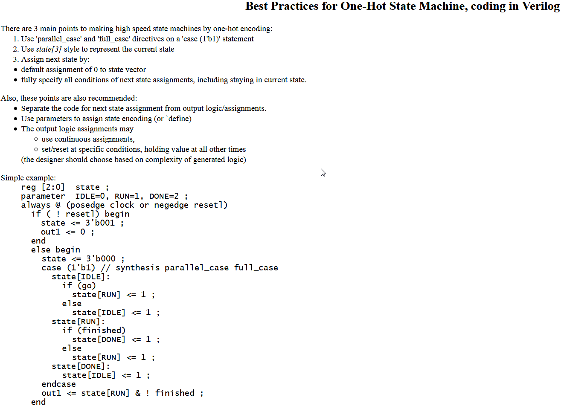

///////////////////////////////////////////////////////
https://github.com/NetFPGA/netfpga/wiki/VerilogCodingGuidelines
Verilog Coding guidelines
Signal naming
Explicit name
All signals are lowercase alpha, numeric and underscore only
Buses are numbered high order to low order: bus[31:0]
Array locations are numbered low to high. e.g. 2048x32 bit RAM:
reg [31:0] mem_array [0:2047];
Do use the same name for the signal at all levels of hierarchy

Constant naming
Use capitals to identify constants: e.g. DEBUG , IDLE

Indenting
Use three spaces per indentation level. Expand tabs to spaces to prevent indentation changing based upon editor settings.

if (this) begin
do something;
end
else begin
do something else;
end

Commenting

- Comment your code. Someone will be coming back to this code in 6 months time, and that person will probably be you .
- When entering multi-line comments, try to use the "/*..*/" commenting rather than putting "//" in front of every line. It makes editing much easier.
- Add the following header to the top of all source code written by us (change the details as necessary):
- ///////////////////////////////////////////////////////////////////////////////
- // vim:set shiftwidth=3 softtabstop=3 expandtab:
- // $Id: reg_file.v 916 2006-04-20 23:23:25Z bob $
- //
- // Module: reg_file.v
- // Project: CPCI (PCI Control FPGA)
- // Description: Register file for access via PCI
- //
- //
- // Change history: 8/18/04 - Implemented DWORD0 (Revision/Version ID)
- // 10/29/04 - Made the RESET signal last longer than
- // a single clock
- // 01/08/05 - dma_rd_mac is now an input as round-robin
- // lookup is used
- // 01/13/05 - split dma_intr into read and write sigs
- //
- ///////////////////////////////////////////////////////////////////////////////

Module declaration/instantiation

Each module should be defined in a separate fime
Use Verilog 2001 style port declarations

Declare inputs and outputs one per line
Group signals logically by their function
Don't instantiate modules using positional arguments. Always use the dot form:
my_module my_module(
.signal (signal),
.a_bus (a_bus),
...
);

Assignment statments
- Sequential elements MUST only have non-blocking assignments (<=)
- Combinatorial should only have blocking assignments (=)
- Don't mix blocking and non-blocking assignments within a code block.

http://academic.csuohio.edu/chu_p/rtl/chu_rtL_book/rtl_chap10_fsm.pdf

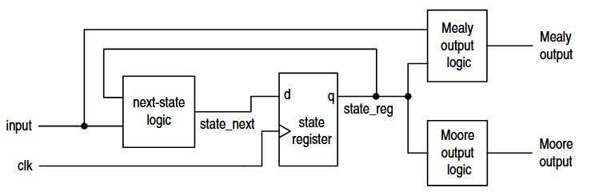

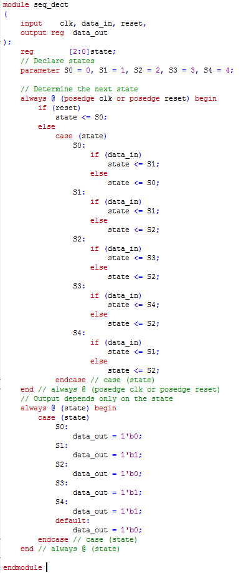

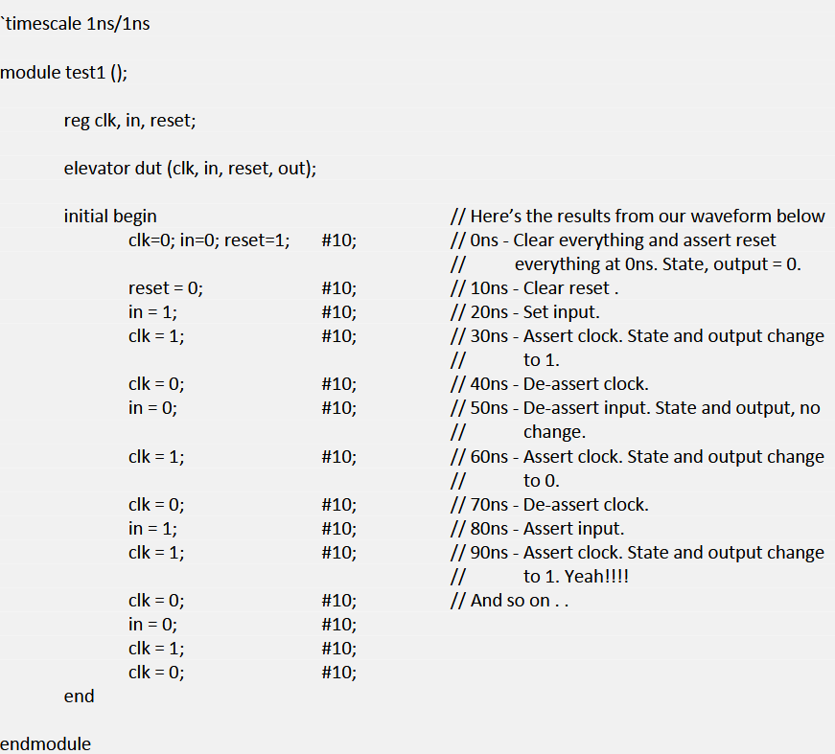

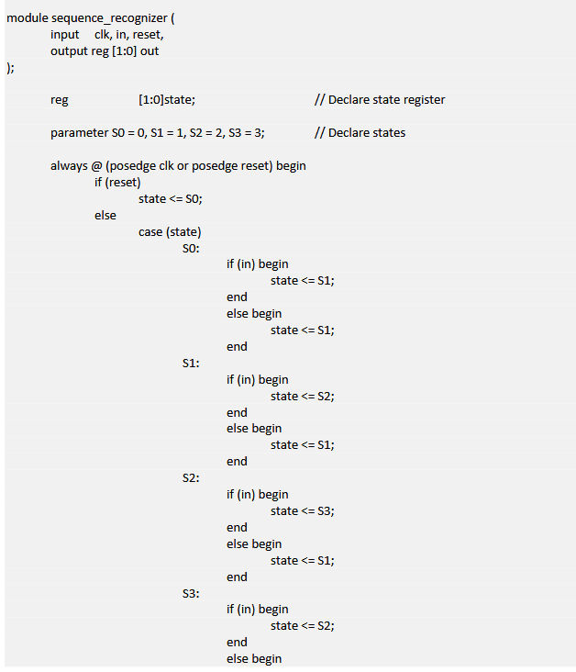

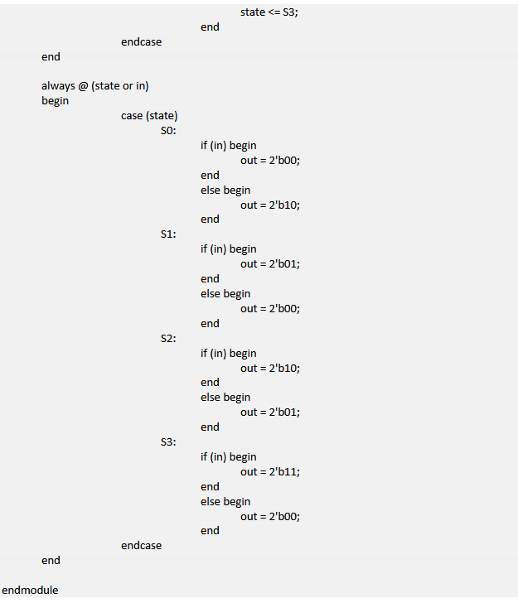
http://tuline.com/wp-content/uploads/2015/11/Finite-State-Machine-Examples.pdf

http://www.fpga4student.com/2016/11/verilog-code-for-alarm-clock-on-fpga.html ++++++

